‘FieldSafe’ App: proposed changes from ‘FieldBase’ App

A key focus of proposed changes is to further enhance the app as a resource for effective but simple management of health and safety for community groups working in conservation.

Set-up requirements in *italics*

**PROJECTS:**

Additions:

*When setting up a Project, add the following:*

**Emergency Services Contacts:**

111 will contact all emergency services;

Local contacts:

Medical Centre: [address/phone]:

Hospital: [address]:

Primary Group Contact: [name/phone]

* *]*

**GOALS**

**Change ‘GOALS’ to ‘OBJECTIVES’**

*In* ***‘Select Objectives****’ in addition to existing list add as below:*

* Native plants established: measurement= number
* Native planting maintained: measurement=Area m2
* Establishing predator control: measurement=trap numbers
* Walking track building: measurement=metres
* Walking track maintenance: measurement=metres
* Species monitoring: measurement=number of species

*When clicking on GOAL/OBJECTIVE the drop down box should just show the OBJECTIVE and the measurement -don’t need the extra box-remove*

**RISKS**

*When clicking on PROJECT/RISKS add*

**Site Hazards [list]**

*[allow up to six lines]*

**Other Hazards [Activity/People]**

* [*allow for up to 8 ]*

*NOTE: Listing these acts as a prompt to people when they complete the Risks*

*IN drop-down Risks list:*

* *remove ‘Working in snake habitat’*
* *add’ Predator control /checking traps’*

*In drop down box for Risk Controls for ‘Predator Control-checking traps’ add:*

* must be competent and confident in trap setting
* check weather before
* check all kit/tools on hand relevant to length of trap line; eg water
* advise ‘buddy’ of leaving and return
* wear disposable or washable gloves when handling traps/disposing of carcases
* tongs used for clearing /cleaning traps
* Use setting tools
* Carry hand sanitiser

**FIELD NOTES**

General

*Either allow to highlight or tick selected risk controls -or add a REMOVE button that allows selected risk controls to be deleted just for that particular event.*

*NOTE:The reason for this is that the Risk assessment should show JUST the actions actually taken to minimise risk for that event*

**STAFF**

*Add phone number to Staff details*

**VOLUNTEERS**

*Add*

‘Pre-existing Medical Conditions checked’ : Yes/No

*Use same button type of button as ‘Induction Status’*

*Add* ***ACTIVITY PRE-START CHECK LIST*** *after ‘Volunteers’ and add to top line also*

*Check list to show:*

* All vehicle licences/ rego current
* Pre-existing medical conditions checked
* Weather checked, appropriate clothing
* Risk assessment checked and completed
* Correct PPE available
* First Aid kit stocked and on site
* First Aider present.
* Project and safety induction completed

*These should be able to be ticked or checked off*

**MANAGE OUTCOMES**

*The first Box should be ‘Outcome’ and show the same dropdown list as listed in PROJECT/GOALS/OBJECTIVES plus ‘Other’*

The second Box should be called ‘Description’ and if Predator Control is selected in the first box then the Description Box should have a drop down list that includes:

* Traps established
* Traps checked
* Catches

And then in the third Box [measurement] -should show as below:

* Traps established- measurement=number
* Traps checked=number
* Catches=number

Rats/number

Possums/number

Mustelids/number

Hedgehog/number

Other/number

See diagram below: NOTE: Must be able to show more than one CATCH number

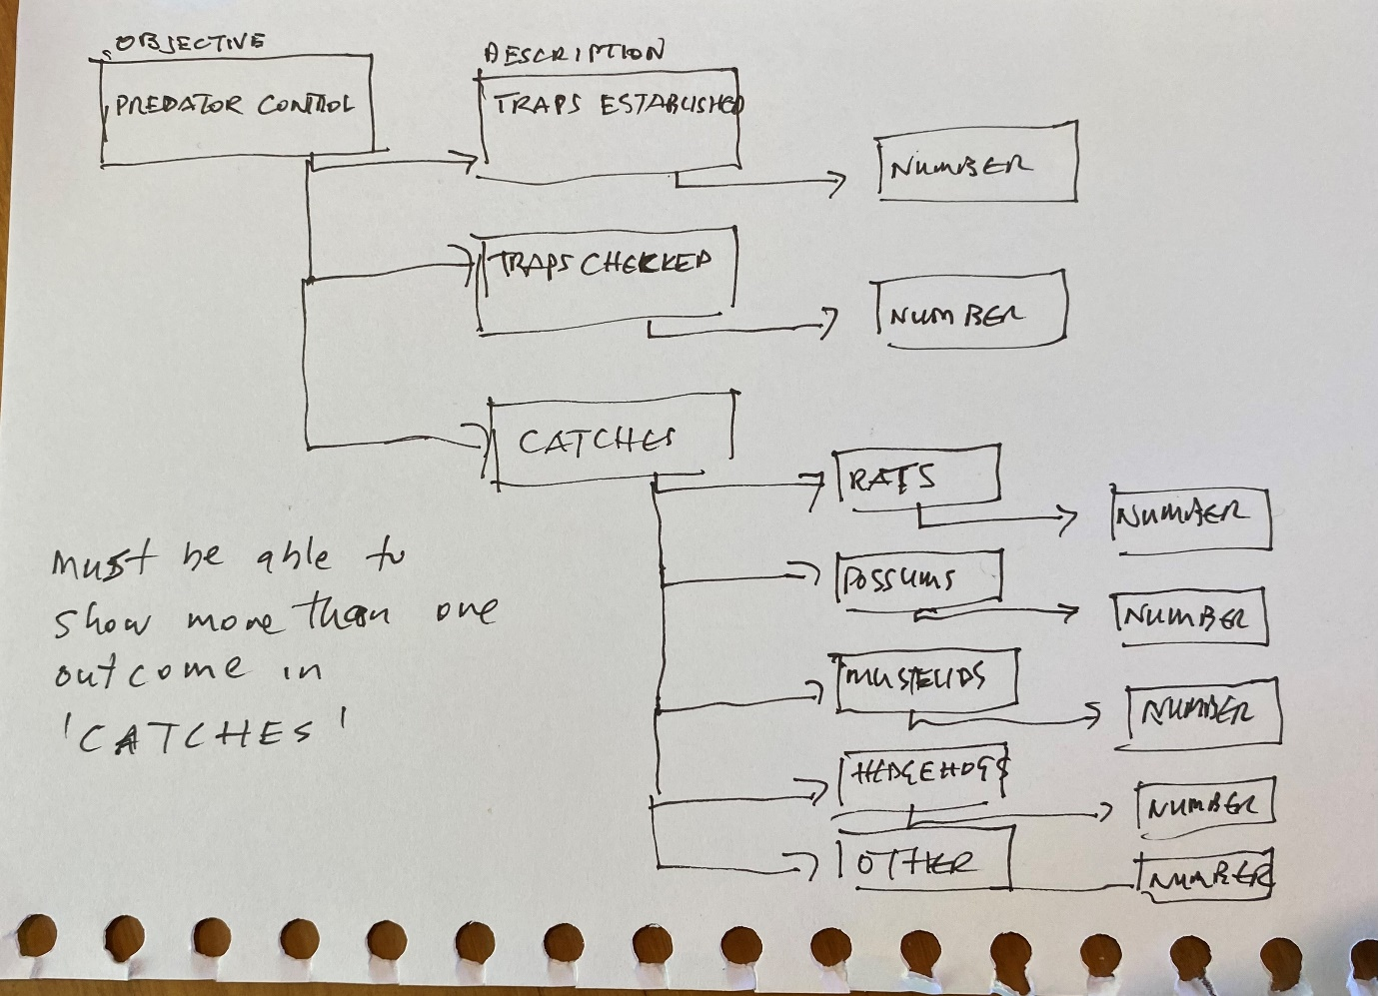

**NOTES**

*Change -One Box for NOTES …second box for INCIDENTS/ INJURIES and YES/NO option.*

*If YES, then Accident Incident Report will link in…see IN Safe Hands toolkit Section 6 for template. [possible?]*

**REPORTING**

First Box should be PROJECT with drop down for Projects list

Second box should repeat the GOALS/OBJECTIVES listed in the PROJECT GOALS/OBJECTIVES

Third box to show time-frame[s].

Other notes>

-Where is all data actually stored ? Dumb question I know

- how do we build in the risk assessment matrix?

-Can we go BACK as well as NEXT?

- Can we make it so that collective data can be gathered? For example,if Auckland Council want to provide this to groups on the basis that they can see collectively what groups using the app are doing on the ground?